
……UNIT Tarampa State School – 2026
Year 5 K-6 Unit 1 |  | Subject / Learning Area - English |  |  |  |  |  | Unit Title – Examining and creating imaginative literary texts |  |  | Duration of Unit – Term 1– 10 Weeks
Overview of Unit | Students engage with a variety of texts by First Nations Australian, Australian and world authors for enjoyment. Texts include films, digital texts and novels, and explore themes of interpersonal relationships through a range of characters and complex sequences of events that may involve flashbacks and shifts in time.  Students explore ways in which a text can reflect time and place, and how ideas are conveyed through characters, setting and events.  Students use texts as models to experiment with storylines, characters and settings in an adaptation of a narrative, and participate in discussion.
Assessment (summative) – what is being assessed | Assessment: 1.1  Responding to literature  Assessment purpose: To read, view and comprehend an imaginative text. To create a written and/or multimodal imaginative text experimenting with ideas from a familiar narrative.
Achievement Standard – coloured text aspect of achievement standard being assessed  Monitoring – underlined is monitored aspect of achievement standard | Year 5  Speaking and listening  By the end of Year 5, students interact with others, and listen to and create spoken and/or multimodal texts including literary texts. For particular purposes and audiences, they share, develop and expand on ideas and opinions, using supporting details from topics or texts. They use different text structures to organise, develop and link ideas. They use language features including topic-specific vocabulary and literary devices, and/or multimodal features and features of voice.  Reading and viewing  They read, view and comprehend texts created to inform, influence and/or engage audiences. They explain how ideas are developed including through characters, settings and/or events, and how texts reflect contexts. They explain how characteristic text structures support the purpose of texts. They explain how language features including literary devices, and visual features contribute to the effect and meaning of a text.  Writing and creating  They create written and/or multimodal texts, including literary texts, for particular purposes and audiences, developing and expanding on ideas with supporting details from topics or texts. They use paragraphs to organise, develop and link ideas. They use language features including complex sentences, tenses, topic-specific vocabulary and literary devices, and/or multimodal features. They spell using phonic, morphemic and grammatical knowledge.
 | Year 5
Relevant content descriptions | Language  Language for interacting with others  • understand that language is selected for social contexts and that it helps to signal social roles and relationships (AC9E5LA01)  Monitoring strategy – Speaking and listening  • understand how to move beyond making bare assertions by taking account of differing ideas or opinions and authoritative sources. (AC9E5LA02)  Text structure and organisation  • describe how spoken, written and multimodal texts use language features and are typically organised into characteristic stages and phases, depending on purposes in texts. (AC9E5LA03) Reading and viewing Writing and creating  • understand how texts can be made cohesive by using the starting point of a sentence or paragraph to give prominence to the message and to guide the reader through the text (AC9E5LA04)  Reading and viewing Writing and creating  Language for expressing and developing ideas  • understand that the structure of a complex sentence includes a main clause and at least one dependent clause, and understand how writers can use this structure for effect. (AC9E5LA05) Reading & viewing Writing & creating  • understand how noun groups can be expanded in a variety of ways to provide a fuller description of a person, place, thing or idea. (AC9E5LA06) Reading & viewing Writing & creating  • Explain how the sequence of images in print, digital and film texts have an effect on meaning. (AC9E5LA07) Speaking & listening Reading & viewing Writing & creating  • understand how vocabulary is used to express greater precision of meaning, including through the use of specialist and technical terms, and explore the history of words. (AC9E5LA08) Reading & viewing Writing & creating Monitoring strategy – Speaking and listening  • use commas to indicate prepositional phrases, and apostrophes where there is multiple possession. (AC9E5LA09) Writing & creating |  |  | Literature  Literature and contexts  • identify aspects of literary texts that represent details or information about historical, social and cultural contexts in literature by First Nations Australian, and wide-ranging Australian and world authors. (AC9E5LE01) Reading & viewing  Engaging with and responding to literature  • present an opinion on a literary text using specific terms about literary devices, text structures and language features, and reflect on the viewpoints of others (AC9E5LE02) Speaking and listening Writing and creating  Examining literature  • recognise that the point of view in a literary text influences how readers interpret and respond to events and characters. (AC9E5LE03) Reading & viewing  • examine the effects of imagery, including simile, metaphor and personification, and sound devices in narratives, poetry and songs. (AC9E5LE04) Speaking & listening Reading & viewing  Creating literature  • create and edit literary texts, experimenting with figurative language, storylines, characters and settings from texts students have experienced (AC9E5LE05) Writing and creating  Monitoring strategy – Speaking and listening |  |  |  |  |  | Literacy  Texts in context  • describe the ways in which a text reflects the time and place in which it was created. (AC9E5LY01) Reading & viewing  Interacting with others  •use appropriate interaction skills including paraphrasing and questioning to clarify meaning, make connections to own experience, and present and justify an opinion or idea (AC9E5LY02)  Monitoring strategy – Speaking and listening  Analysing, interpreting and evaluating  • explain characteristic features used in imaginative, informative and persuasive texts to meet the purpose of the text. (AC9E5LY03) Reading & viewing  • navigate and read texts for specific purposes, monitoring meaning using strategies such as skimming, scanning and confirming. (AC9E5LY04) Reading & viewing  • use comprehension strategies such as visualising, predicting, connecting, summarising, monitoring and questioning to build literal and inferred meaning to evaluate information and ideas. (AC9E5LY05) Reading & viewing Monitoring strategy – Speaking and listening
Moderation – identify opportunities to moderate at multiple junctures (when/who with/ what / next steps etc) | Week 5 Term  Before (before assessment takes place and at the planning stage)  (Week 9 Term 4 for 2026 Before planning)  Aligning targeted aspects of the achievement standard being assessed with appropriate curriculum elements.  Calibrating understandings about how to make judgements using sample student or teacher created sample responses to summative assessment.  Quality assuring the teaching and learning sequence and reviewing the selection of pedagogical approaches, practices and teaching strategies to differentiate teaching and learning. |  |  | Term 1 Week 8  After (after assessment takes place but before it is graded)  Calibrating judgements about student work by grading sample student responses to summative assessment, representing evidence at, above and below the ‘C’ standard against the targeted aspects of the achievement standard being assessed.  Confirming judgements about student work by moderating sample student responses to summative assessment, representing evidence at ‘A’, ‘B’, ‘C’, ‘D’, ‘E’ (or equivalent) levels of achievement – against the targeted aspects of the achievement standard being assessed.  Using calibrated and confirmed teacher judgements to award a overall level of achievement for summative assessment for all students |  |  |  |  |  | Term 2 Week …  End (Engaging in moderation processes at the End of the reporting period.)  Calibrating judgements for reporting by grading sample assessment folios, representing evidence at, above and below the ‘C’ standard.  Confirming judgements for reporting by moderating sample student assessment folios, representing evidence at ‘A’, ‘B’, ‘C’, ‘D’, ‘E’ (or equivalent) level of achievement – against the targeted aspects of the achievement standard taught and assessed in the reporting period.  Using calibrated and confirmed understandings about making standards-based judgements on folios to ensure accuracy of judgements for reporting on student achievement for all students.
What do my students need to know / understand? |  |  |  |  |  | What do my students need to be able to do?
Year 5 Know (Knowledge / Understanding)  . Reading and Viewing  - That imaginative texts are created to inform, influence, and/or engage audiences.  - That authors use characters, settings, events and point of view to develop ideas.  - That texts are shaped by context — social, cultural or historical.  - How language choices (e.g., vocabulary, idioms, descriptive details) help establish context.  - That readers identify audience and purpose by examining the author’s choices.  - How to locate and use literal and inferred meaning to support interpretations.  - How ideas in texts are shown through:  - relationships between characters  - actions and motivations  - descriptions of setting  - events that influence the storyline.  Speaking and Listening (monitoring strategy)  - That spoken texts should be clear, sequenced and suitable for an audience.  - That ideas can be shared and extended collaboratively with peers.  - That imaginative ideas can be built by experimenting with figurative language, settings, and characters from a narrative.  Writing and Creating  - That imaginative texts are written for a specific audience and purpose.  - That narratives use text structures such as paragraphs with logically sequenced ideas.  - That cohesive devices (pronouns, connectives, openers) help link ideas.  - How to use complex sentences, verb tenses, noun groups, and topic-specific vocabulary.  - That narratives use literary devices including:  - figurative language (simile, metaphor, personification)  - imagery  - dialogue  - characterisation and description.  - How to adapt elements of a familiar narrative:  - same characters/settings  - same context  - extend or change the plot (prequel, sequel, new event, alternative ending).  - How to edit for meaning, grammar, punctuation and spelling. |  |  |  |  |  | Year 5 Do (Skills / Application)  Reading and Viewing  - Read and comprehend an unseen narrative excerpt independently.  - Identify the audience and author’s purpose.  - Explain the context (social, cultural, historical) and justify with evidence.  - Identify and describe main characters, settings and key events.  - Evaluate the importance of events for a main character using text evidence.  - Identify the narrative point of view.  - Explain how point of view shapes the reader’s feelings or opinions.  - Annotate and reference relevant sections of the text in responses.  Speaking and Listening (monitoring only)  - Discuss ideas for narrative adaptation with a partner or group.  - Experiment orally with ideas for characters, settings, plot and figurative language.  - Share a spoken outline of their intended narrative adaptation.  Writing and Creating  - Plan an imaginative narrative adaptation using elements from the original story.  - Reflect on the original author’s audience and purpose and adapt appropriately.  - Extend the storyline using context, characters, point of view and settings.  - Write a sequenced narrative using:  - logically ordered paragraphs  - cohesive devices to link ideas  - simple, compound and complex sentences  - consistent tense  - topic-specific and precise vocabulary  - a wide range of verb and noun groups  - dialogue (correctly punctuated).  - Use literary devices including imagery, simile, metaphor and/or personification.  - Review and edit their writing for:  - structure and clarity  - grammar, punctuation and spelling  - meaning and sequencing.  - Optionally publish their narrative, including multimodal elements if desired.
How will I cater for the needs of all my students? How will I Include all of my students in the teaching, learning and assessment process? What reasonable adjustments / special provisions do I need to consider? How will I differentiate around environment, process, content and product (Maker model)?

Students below |  |  | Students at |  |  |  |  |  | Students above
Special provisions in the conditions of assessment are applied consistently across the school. All students are entitled to demonstrate their knowledge, understanding and skills in response to assessments. Schools and teachers support all students to participate in assessment and demonstrate the full extent and depth of their learning. Special provisions in the conditions of assessment reflect differentiation, or adjustments, made to curriculum delivery. Special provisions are not adjustments to the relevant achievement standard on which student work is judged. They do not involve compensating for what the student does not know or cannot do (DoE 2018, p. 3). |  |  |  |  |  |  | 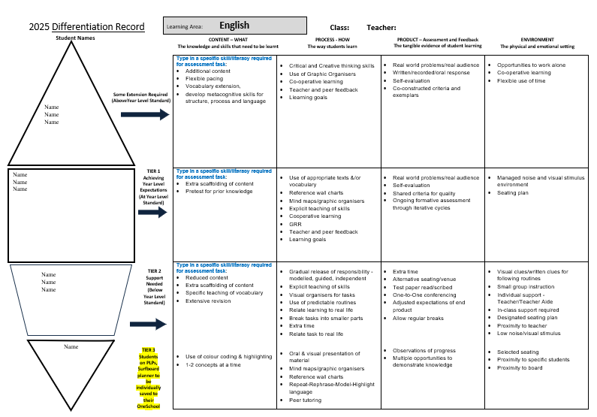
Types of special provision:  Special provisions in the conditions of assessment may include…  • presentation – changing how an assessment appears or is communicated to a student from the regular format. E.g. being read to rather than reading unless reading itself is what is being assessed.  • response – allowing students to complete assessments in different ways such as using computer software or an assistive device to solve and organise problems when this does not compromise what is specifically being assessed.  • setting – changing location including the physical or social conditions in which the assessment is completed.  • timing – allowing the student a longer time to complete the assessment, or change the way the time is organised or when the assessment is scheduled. |  |  |  |  |  |  | Student/s requiring an ICP
 | Teaching and Learning Sequence |  |  |  | Reading |  |  |  |  | Differentiation |  | Resources
Week 1  Sequence 1 | Learning Objective:
Week 2
Sequence 1 continued…

Week 3
Sequence 2

Week 4
Sequence 2 continued
Week 5
Sequence 3
Week 6
Sequence 3 continued…
Week 7
Sequence 4
Week 8
Sequence 4 continued
Week 9
Sequence 5

Week 10  Sequence 5 continued.. | ^{Review}
Monitor
How will I track and monitor my students’ progress throughout this unit and provide effective feedback? | Diagnostic: Progress monitoring, DIBLES  Monitoring:  Summative: Year 5 Assessment task 1.1
Unit overview – Teaching, learning and assessment
Week 1 | Week 2 | Week 3 | Week 4 | Week 5 | Week 6 | Week 7 | Week 8 | Week 9 | Week 10
Sequence 1 |  | Sequence 2 |  | Sequence 3 |  | Sequence 4 |  | Sequence 5
Reading and viewing, Writing and creating Examining and creating imaginative literary texts
Literacy knowledge, concepts and skills
 |  |  |  |  |  |  | Yr 5 Assessment task 1.1

End of Unit Notes

